Chapter 17, Problem 26.

Find the Fourier series representation of the signal shown in Fig. 17.64.

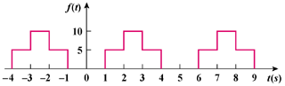

Figure 17.64
For Prob. 17.26.

